|  |  |  |
| --- | --- | --- |
| River raid : Timmy’s playtime | | |
| Game Design Document | | |
|  | | |
| 3D Scrolling shooter | | |
|  | | |
|  | | |
|  | | |
| By Curry & Beans  Abhyudaya Sardesai | | |
| Andre Borja  Naomi Freire  Nicholas John | | |
|  | | |
|  | | |
|  | Table of Contents  Overview  3 Cs  Features  Production  UI  Art  Audio  Tech |  |

# Overview

## Description

Remake of the Atari classic, River Raid. Brought into modern systems with a 3D look, and a new concept.

## Goals

Reimagine an existing game, but without losing its spirit.

## Pillars

Three pillars that will help inform your design decisions.

1. Controls – the game uses the Atari controller scheme (joystick and a single button), so we had to think the gameplay around this restriction.
2. Replayability – with the highscore mechanic, the player is encouraged to attempt the game more than once, to try and beat their score.
3. Visuals – the gameplay takes place in the mind of a child playing in their backyard. The visuals follow suit, representing how they envision the scene.

## Hook

They arcade-y nature of the game, with simple-yet-satisfying loop should engage the player and encourage further attempts to break their own highscore.

# 3 Cs

## 

## Character

You play as a toy plane, following a “river”, destroying enemy blimps, and ships, and going through rings to increase your speed and score.

## Camera

This game will have a third person camera, with the pane centered. It will have a view slightly from above.

## Controls

Her controls are based on the constraints of an Atari controller: one joystick and one button. The joystick (or WASD) will control the plane’s movement direction, while the button will fire a missile forward.

# Features

## Enemies (Blimps and ships)

These will be the targets the player should try to shoot down, especially if one blocks the way towards a ring.

## Rings

Rings will guide the player’s path. Going through them will not only increase the score, but also give a temporary boost to the flight speed.

## Highscore

You have a score counter in your screen, showing you how many points you acquired on your run through the level.

# Production

## Kanban Board

## https://trello.com/b/dIy2242Q/not-an-et-remake

## Team Members and Responsibilities

|  |  |
| --- | --- |
| Team Member | Main Responsibilities |
| Abhyudaya Sardesai | Lead Programmer |
| Andre Borja | Project Manager, Sound designer, Programmer, UI designer |
| Naomi Freire | 3D Artist, 2D Artist, Lighter |
| Nicholas John | Level Designer, Environmental Artist |

## Risks and Mitigation

Identify any risks and their possible mitigations. Add more rows as needed. Check example below.

|  |  |
| --- | --- |
| Risk | Mitigation(s) |
| Team has never made a rogue-lite | Prioritize procedural content generation tasks, find online learning resources |
| Atari controller is limiting | Explore what can be done to augment the power of the few buttons available |

## Publishing

# <https://andreborja.itch.io/river-raid-remake>

# Art

A child’s wild imagination come to life.

For the modelling of the gameplay objects, the main references were the spaceships of Lilo & Stitch and Hotwheels: Unleashed.

[https://br.pinterest.com/nanahfreire/riverraid/](https://br.pinterest.com/nanahfreire/riverraid/?invite_code=b11f9d54ed6c4bd39ce3f2e6ec24ef4d&board_collab_inviter=True&inviter_user_id=775393398252275787)

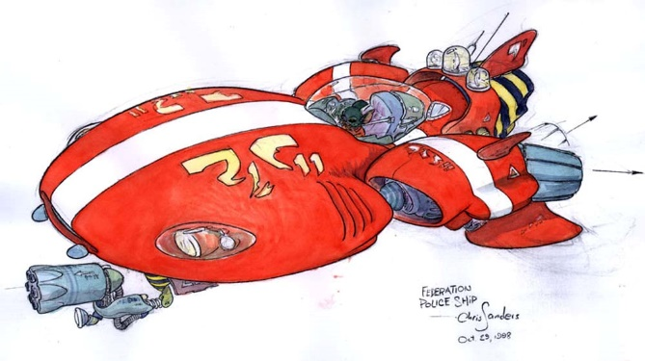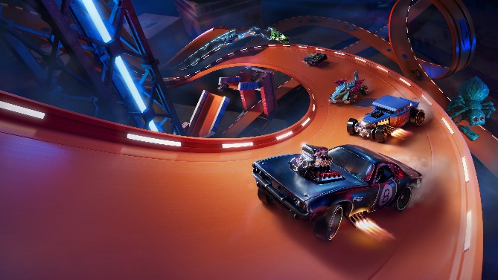

# Tech

The game was made with the Unity engine, using Text Mesh Pro, Unity’s New Input System, and Probuilder as packages to help build the game.

# Audio

We tried to simulate a child playing, so sounds related to the combat side of the game are voice overs. Other sounds are regular clips, obtained online. Gameplay soundtrack is a fast-paced 80’s pursuit-style song, to match the energy of the game loop. Clips not recorded ourselves, where obtained from freesound.org or zapsplat.com.

# UI

A minimalistic UI was chosen for this project, to avoid intrusion in the gameplay. Two small panels imitating the plane’s dashboard will have a speedometer and a score counter.

# Post-mortem

## What went right

* Insert text

## What went wrong

* Insert text

## What we learned

* Insert text